Love Love

America America


Love Love

America America

Love Love

America America

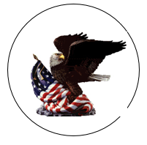
American American

Pride Pride

American American

Pride Pride

American American

Pride Pride

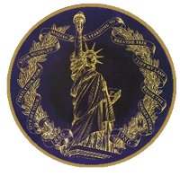

World of World of
Freedom Freedom

World of World of
Freedom Freedom

World of World of
Freedom Freedom

Sewing the Seed Sewing the Seed
of of
Freedom Freedom

Sewing the Seed Sewing the Seed
of of
Freedom Freedom

Sewing the Seed Sewing the Seed
of of
Freedom Freedom

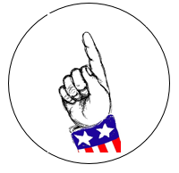
America America

First! First!

America America

First! First!

America America

First! First!

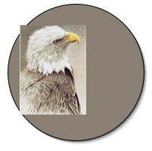

Democratic Strength
Power Together

Democratic Strength
Power Together

Democratic Strength
Power Together

Free the
World Liberty

Free the
World Liberty

Free the
World Liberty
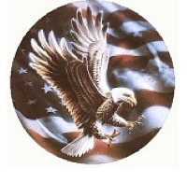

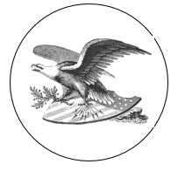

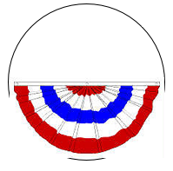



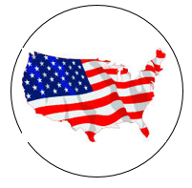

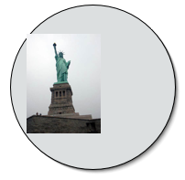

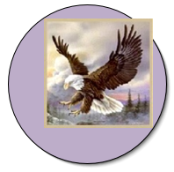

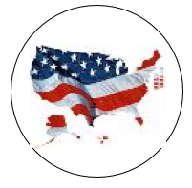

Unite Unite

Unite Unite

Unite Unite


VOTE! VOTE!

VOTE! VOTE!

VOTE! VOTE!



