Democratic Convention | Republican Convention
August 25-28, Denver, Colorado. | September 1-4, Minneapolis-Saint Paul, Minnesota
http://www.demconvention.com/ | http://www.gopconvention2008.com/

MAKE DIFFERENT SIZE POLITICAL CAMPAIGN BUTTONS
The templates on our Political Button Templates CDs are sized and sorted so you can easily make campaign buttons in any, or all of the following sizes: 1-1/2, 1-3/4", 2-1/4", 3", 3-1/2", BAM 2-1/4" and BAM 3"

THE ADVANTAGE YOU HAVE OVER LARGER BUTTON MAKERS
One of the things is that politicians always seem to need to have their buttons in a hurry and are willing to pay for expedited shipping to get the buttons to them for their next event. The advantage you have is the ability to make buttons for local politicians, and not have to charge them rush shipping. If you get your production techniques down, you could even provide SAME DAY Service, which is something larger button-makers typically can't offer.

A LIST OF WHAT YOU NEED TO MAKE POLITICAL CAMPAIGN BUTTONS
If you want to make political campaign buttons, here's what you will need.
- You will need a computer.
- You will need is a graphics application to design your buttons. You can use just about any graphics program that allows you to work with text and graphics can be used to create artwork for your buttons.
- You also are going to need a way to print the artwork for your buttons.
- You will need a button machine.

WHAT CAN YOU TELL ME ABOUT BUTTON MACHINES?
Button machines are NOT all the same! Some are easy to operate... many are not. Some will make professional quality buttons... many do not. If you plan to sell the buttons you make, you are going to need a button machine that's fast and can make professional quality buttons.
What's the difference, you ask? Inexpensive button machines are typically made of lesser materials like plastic, or plastic-like compounds. While they are cheap and easy to produce, you need to keep in mind that the supplies used to make a button are made of steel. So when you make a button with one of those machines, you are using plastic to bend and crimp steel. That's like trying to cut through a tough steak with a plastic knife! And that's why people who use plastic button machines encounter so many problems making buttons. Problems like an unacceptably high percentage of their buttons not going together, or buttons that fall apart shortly after being made. Or having paper and plastic sticking out the sides of their buttons. Buttons having these type of poor quality issues cannot be considered "professional-quality". Professional quality buttons have, smooth, tightly crimped edges and they won't fall apart in your customers hands. And they won't have paper or plastic sticking out the sides.
The button machines we offer made of solid steel, so they are durable and dependable. And they make professional-quality buttons that have smooth, tightly crimped edges. To see a quick video that shows how easy it is to make buttons with our button machines, click : http://www.buttonsonline.com/movie/video1.html

WHAT'S THE BEST SIZE FOR POLITICAL CAMPAIGN BUTTONS?
I usually recommend making political campaign buttons in the 2-1/4" size. That's because 2-1/4" parts are less expensive than 3" parts and you can get twice as many designs on a printed page. And 2-1/4" is also the size most politicians ask for!

WHICH BUTTON MACHINE SHOULD I GET?
If you want to make political campaign buttons, I recommend our Model 225 Starter Kit. The Model 225 is more expensive than the plastic button machines I just talked about, but aren't going to outgrow in a week or two. With our Model 225 kit, you'll receive the Model 225 button press, an AC-1 circle cutter, and the button-making supplies necessary to make 250 pin-back buttons, all for only $329.95. You'll also receive one of our premium Button Designs CDs, FREE of Charge. These CDs normally sell for $59.95 each. If you wish, your premium CD can be either one of our Political Button Templates CDs. You'll also receive a coupon you can use to have our graphic design professionals create a FREE button design that we can email to you if you're in a hurry.
So, if you already have a computer (or access to one), it's truly possible to start a highly profitable, home-based business making political campaign buttons for an investment of less than $400.
The AC-1 Circle Cutter is the BEST hand-held circle cutter on the market today! The AC-1 can be purchased for only $89.95 which includes FREE shipping within the continental U.S.
There is also a Punch Circle Cutter. Here’s a video demo: http://www.buttonsonline.com/movie/punchcutter.avi
This particular Punch Cutter would be used for making 2-1/4" buttons, but all our Punch Circle Cutters operate in exactly the same fashion.
If you have any questions about button-making, button machines, or if you'd like to place an order by phone, give us a call toll-free at (800) 243-8293 or (623) 869-8233.

Supplies:
http://www.buttonsonline.com/parts.html

Sizes to make
- 1”
- 1 ½”
- 2 ¼”

Paper
20#

Words
Words | Artwork |  | Words | Artwork
1. √America First | #10 |  | 2. United States First
3. ∫ Love America | #14 |  | 4. USA Your Responsibility
5. Love the United States |  |  | 6. √World of Freedom | #16
7. Love the USA |  |  | 8. √Free the World | #16
9. Stand Up for America |  |  | 10. √Sewing the Seed of Freedom | #9
11. √American Pride | #2 |  | 12. √Unite | #1
13. √Democratic Power | #5 |  | 14. √Strength Together | #5
15. √Love American Style | #14 |  | 16. √Liberty for All | #16
17. Democratic National Convention 2008 - Denver, Colorado |  |  | Republican National Convention 2008 - Minneapolis-Stain Paul, Minnesota

Artwork
I can make any of these into circles. I just want to see which you like/dislike so we can rank or remove them before I waste time modifying them.

Good

 | 
1 | 2

3 | 4
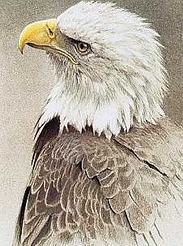 5 |  6
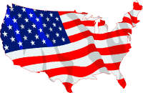 | 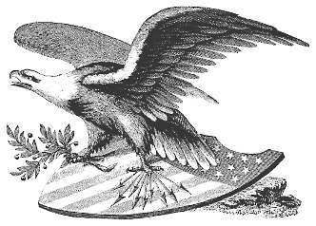
7 | 8
 | 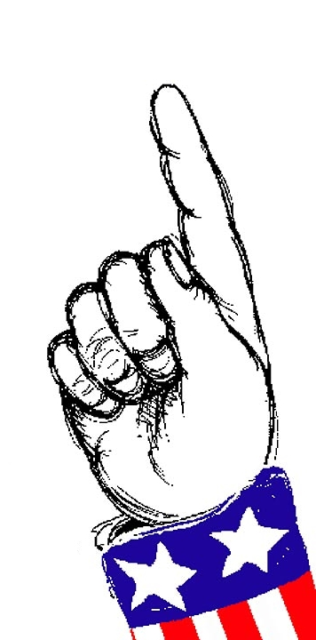
9 | 10
 | 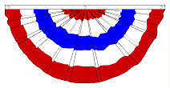
11 | 12
 | 
13 | 14
 | 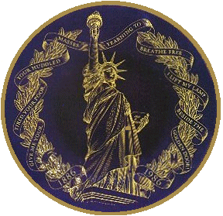
15 | 16
 | 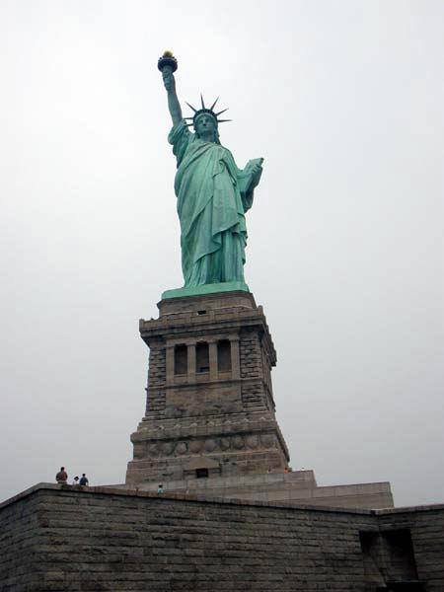
17 | 18

Bad

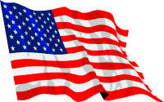 19 | 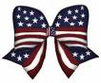 20 |  21
 22 | 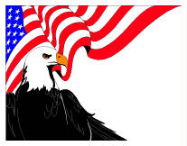 23 |  24
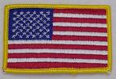 25 |  26 | 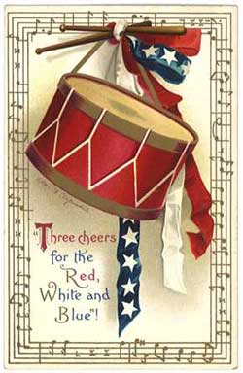 27
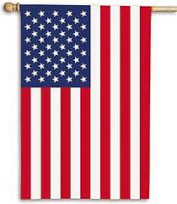 28 |  29 |  30
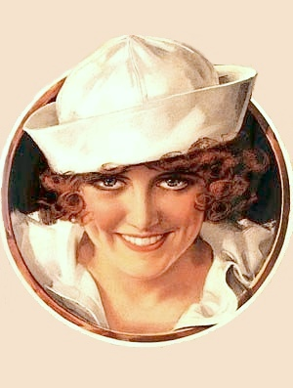 31 |  32 | 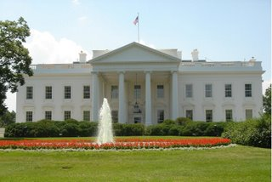 33
 34 | 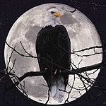 35 | 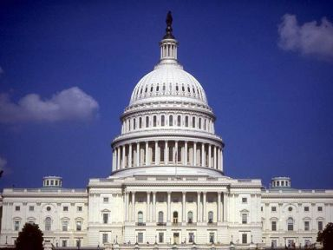 36
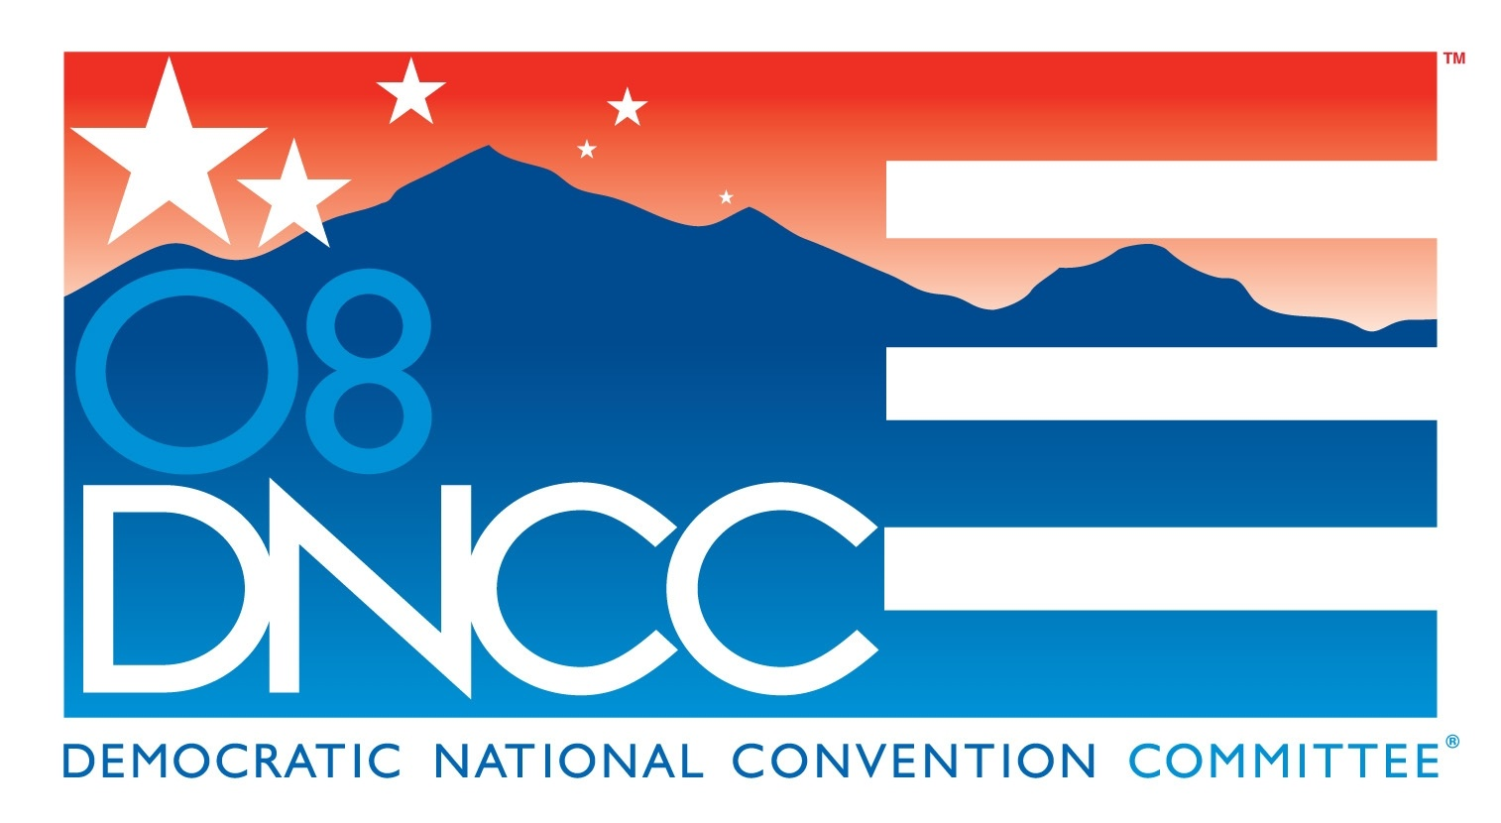 | 

